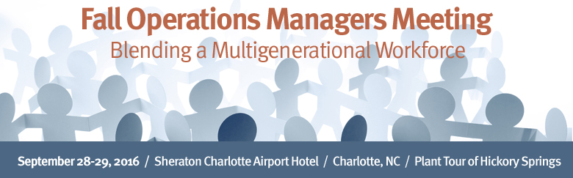

Workshop Discussion Guide

General Observations and Notes

Recruitment Discussion

- What are the most successful aspects of your recruiting program?

- In what areas would you like to improve?

- Which recruitment sources do you use specifically to identify hourly and salaried applicants? Are you exploring alternative channels?

- How easily can applicants move through your recruitment process from application to offer? Are there areas you can streamline?

- What selling techniques do you use to attract hourly and salaried Millennials?

- How well does your interviewing process assess overall fit? Have you seen a correlation with retention?

- What interviewing tools can you incorporate to ensure a more highly engaged employee? How will you roll this out to hiring managers?

- How well does your onboarding process help new hires integrate into your culture?

Retention / Engagement Discussion

- What are your most prevalent conflicts between Boomers, Generation X and Millennials?

- How are you addressing those conflicts? Any best practices you can share?

- How well are you engaging your hourly and salaried Millennial staff?

- Describe your performance review process. Are you moving toward a coaching model?

Total Rewards Discussion

- What is working well in your total rewards program?

- What areas need improvement?

- What total reward needs are different generations expressing?
Eg. Compensation, benefits, work-life balance, mentoring, career development, etc.

- To what extent have you customized your total rewards programs for different generations?

Succession Planning Discussion

- How is your company facing the impending “brain drain” of Boomers? Do you know your demographics of potential retirees?

- How are you handling knowledge transfer from your Boomers? Do you use any technology tools?

- What programs do you have to retain your Boomers while helping them phase out toward retirement?

- How are you grooming your high potential next generation staff?

OVERNIGHT HOMEWORK

- What are the biggest gaps in your recruitment, engagement, total rewards, and succession planning programs?

- What areas of lowest hanging fruit can be immediately addressed when you return to the office? Who can support you in the roll out?

- What longer term priorities should you incorporate into your HR/operations planning roadmap?

- In what specific areas would you like help from your AWPA colleagues tomorrow?

AN ACTIONABLE ROADMAP TO ENGAGE

YOUR MULTIGENERATIONAL WORKFORCE

- Take an assessment of your generational demographics:
- Expected Boomer retirements
- High potential Generation X employees
- At-risk Millennial employees

- Create an infrastructure to regularly assess the engagement needs of each generation.

  - Use a robust engagement survey.
  - Employ Passiontivity or other coaching tools.
  - Encourage bottom up feedback. Create a feedback loop mechanism.

- Rethink your recruitment program.
- Explore additional sources to attract highly motivated candidates.
- Solicit feedback from hiring managers and new hires to improve your application, interviewing and onboarding processes.

- Re-examine your total rewards program. Ask Boomers, Generation X and Millennials to identify areas you can customize.

- Review your career pathing programs for hourly and salaried workers.
- Ask Generation X and Millennials how they would like to grow.
- Help hiring managers identify career advancement opportunities.
- Groom your high potential employees for succession planning.

- Create a knowledge transfer program to prepare for your impending Boomer retirements.

  - Consider retention programs such as phased retirement.
  - Integrate mentoring / reverse mentoring into your culture.
  - Explore knowledge transfer technology tools.

- Host generational dialogues to foster respect for diversity and inclusion. Conduct regular focus groups, especially among Millennials, then incorporate suggestions where possible to show them you were listening!

- Discuss with your HR/Operations team the measurable steps you will commit to taking over the next 3 months, 6 months, and 12 months.

